Social99 Feedback

1. When I was adding a password for new site. It is showing Password is already in use. Not tell the user that password is used or not.
2. Accepting the End date Before Start date.

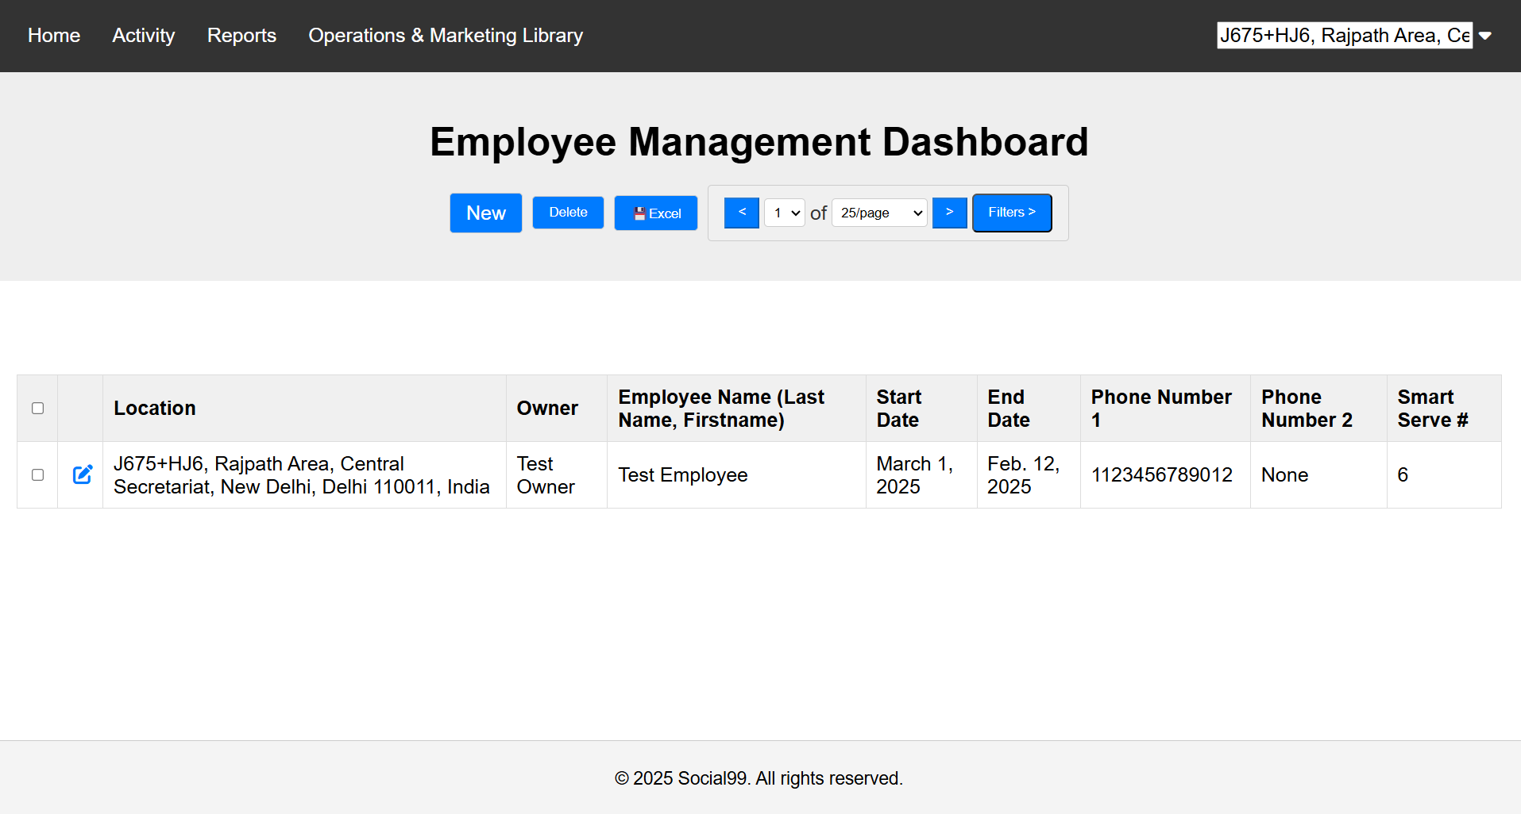

1. Employee Compensation Accepting End Date Before Effective Date. Also Added Multiple Compensation for same Employee.

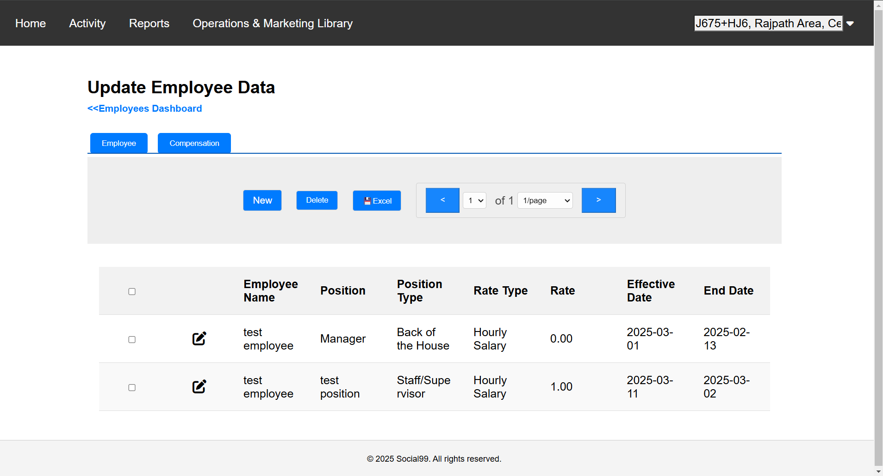

1. Showing Two Roles for same Employee. And also no check for input in payroll  
     
   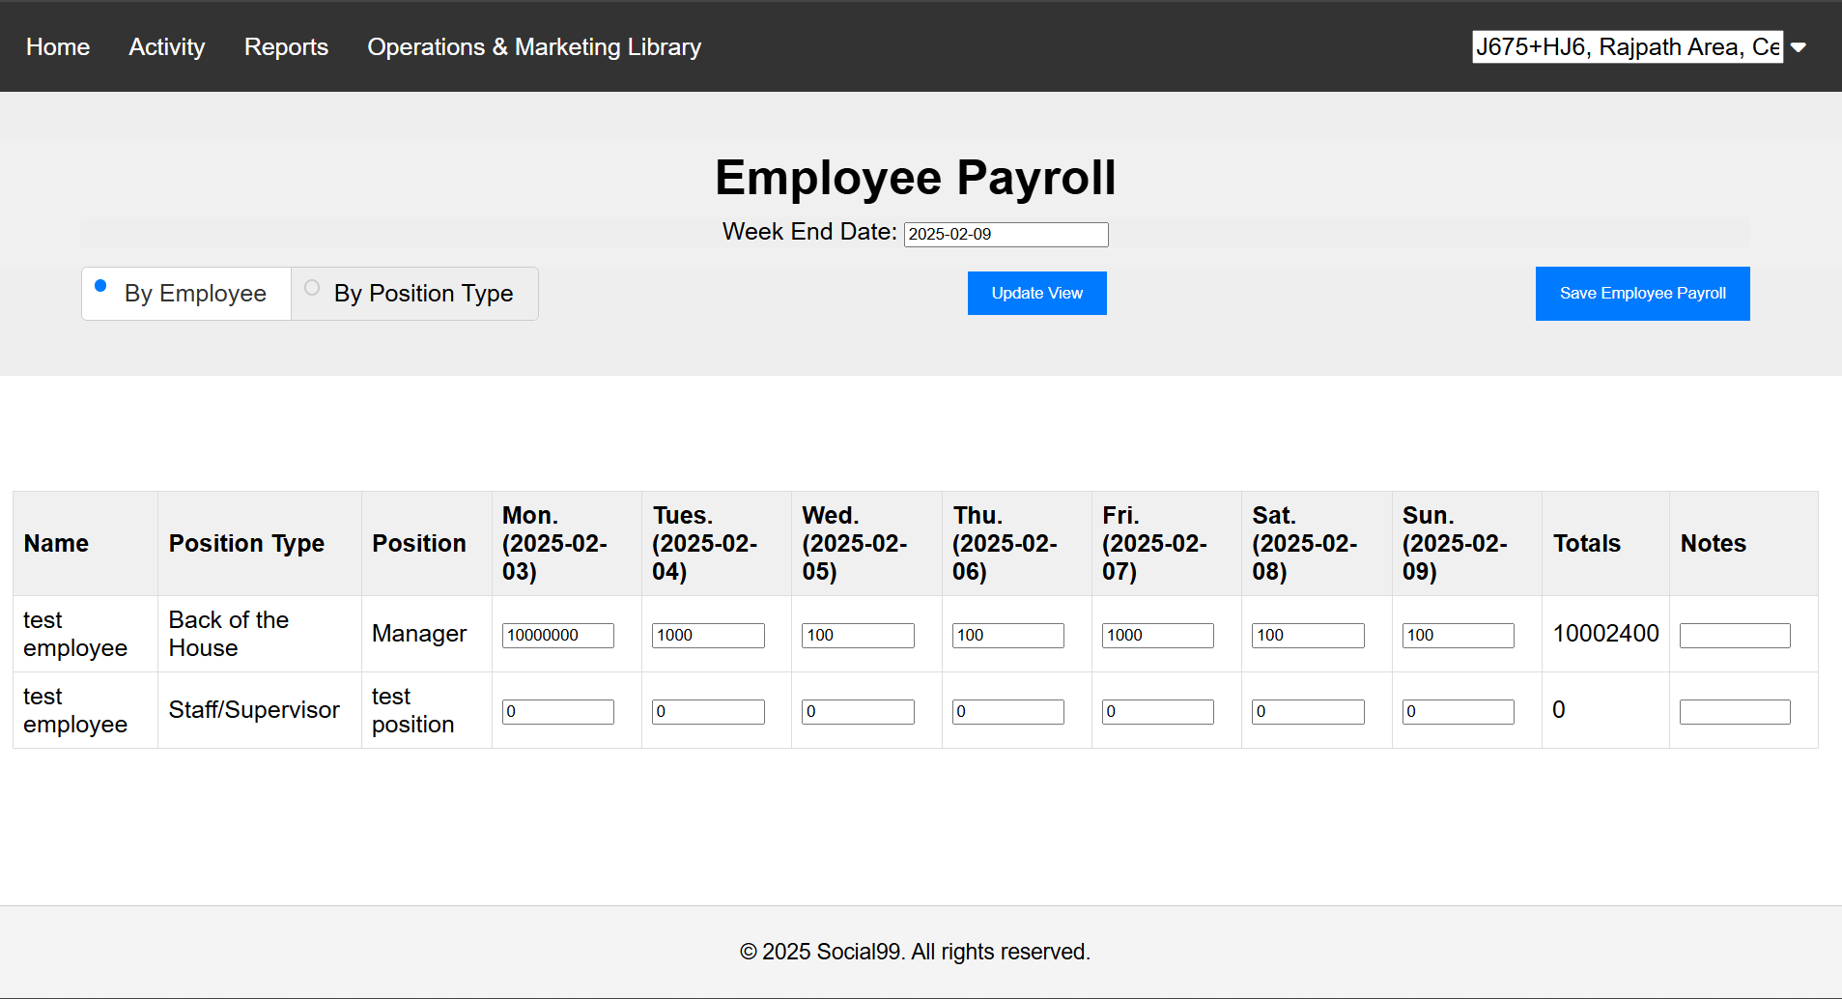
2. Tried to run the Payroll report showing error

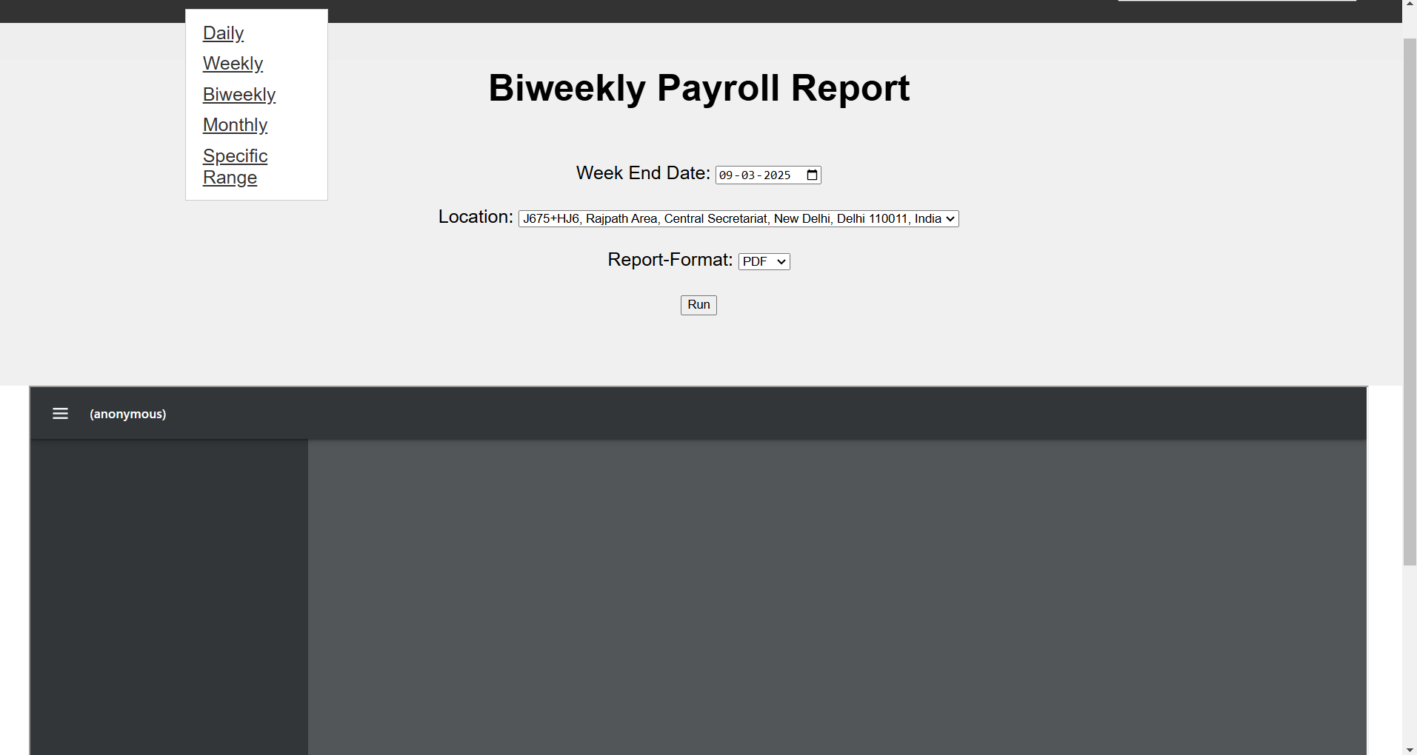

1. Employee Delete Still Showing the employee’s name and information in payroll.

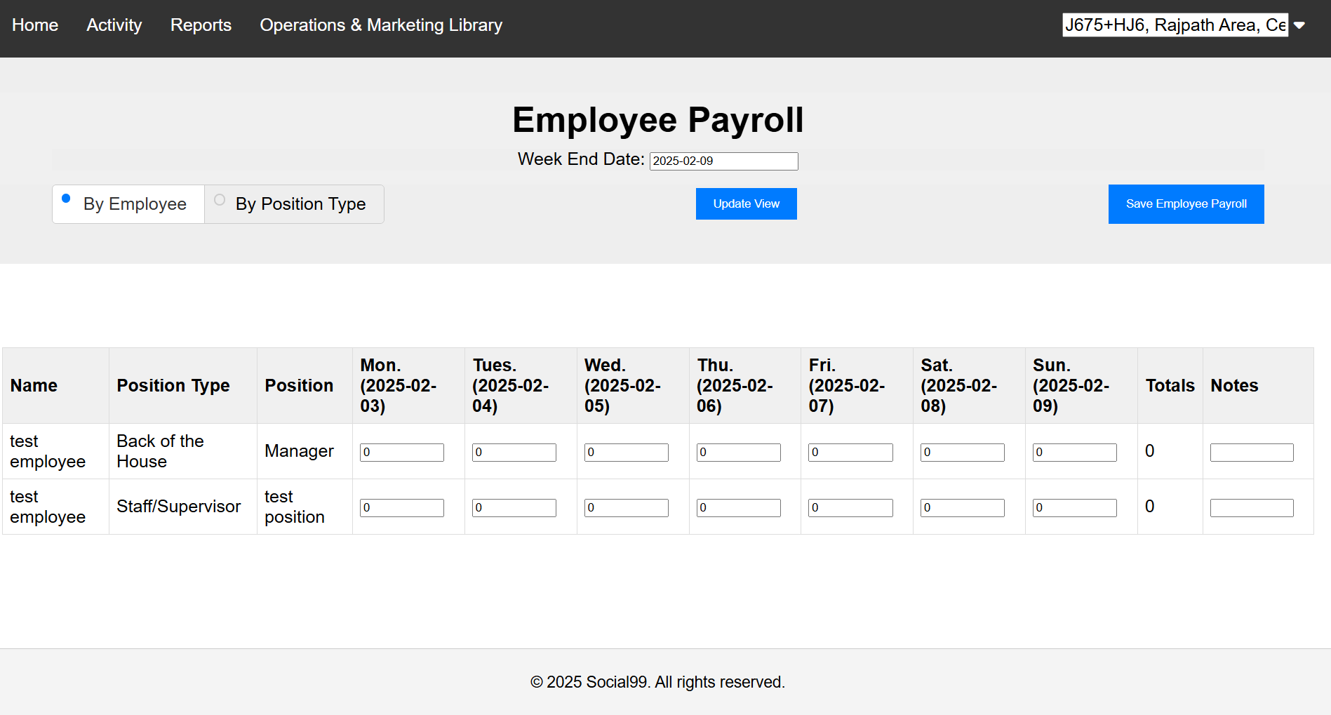

1. Try to create a new site with password “12345678”. It not show proper error message.

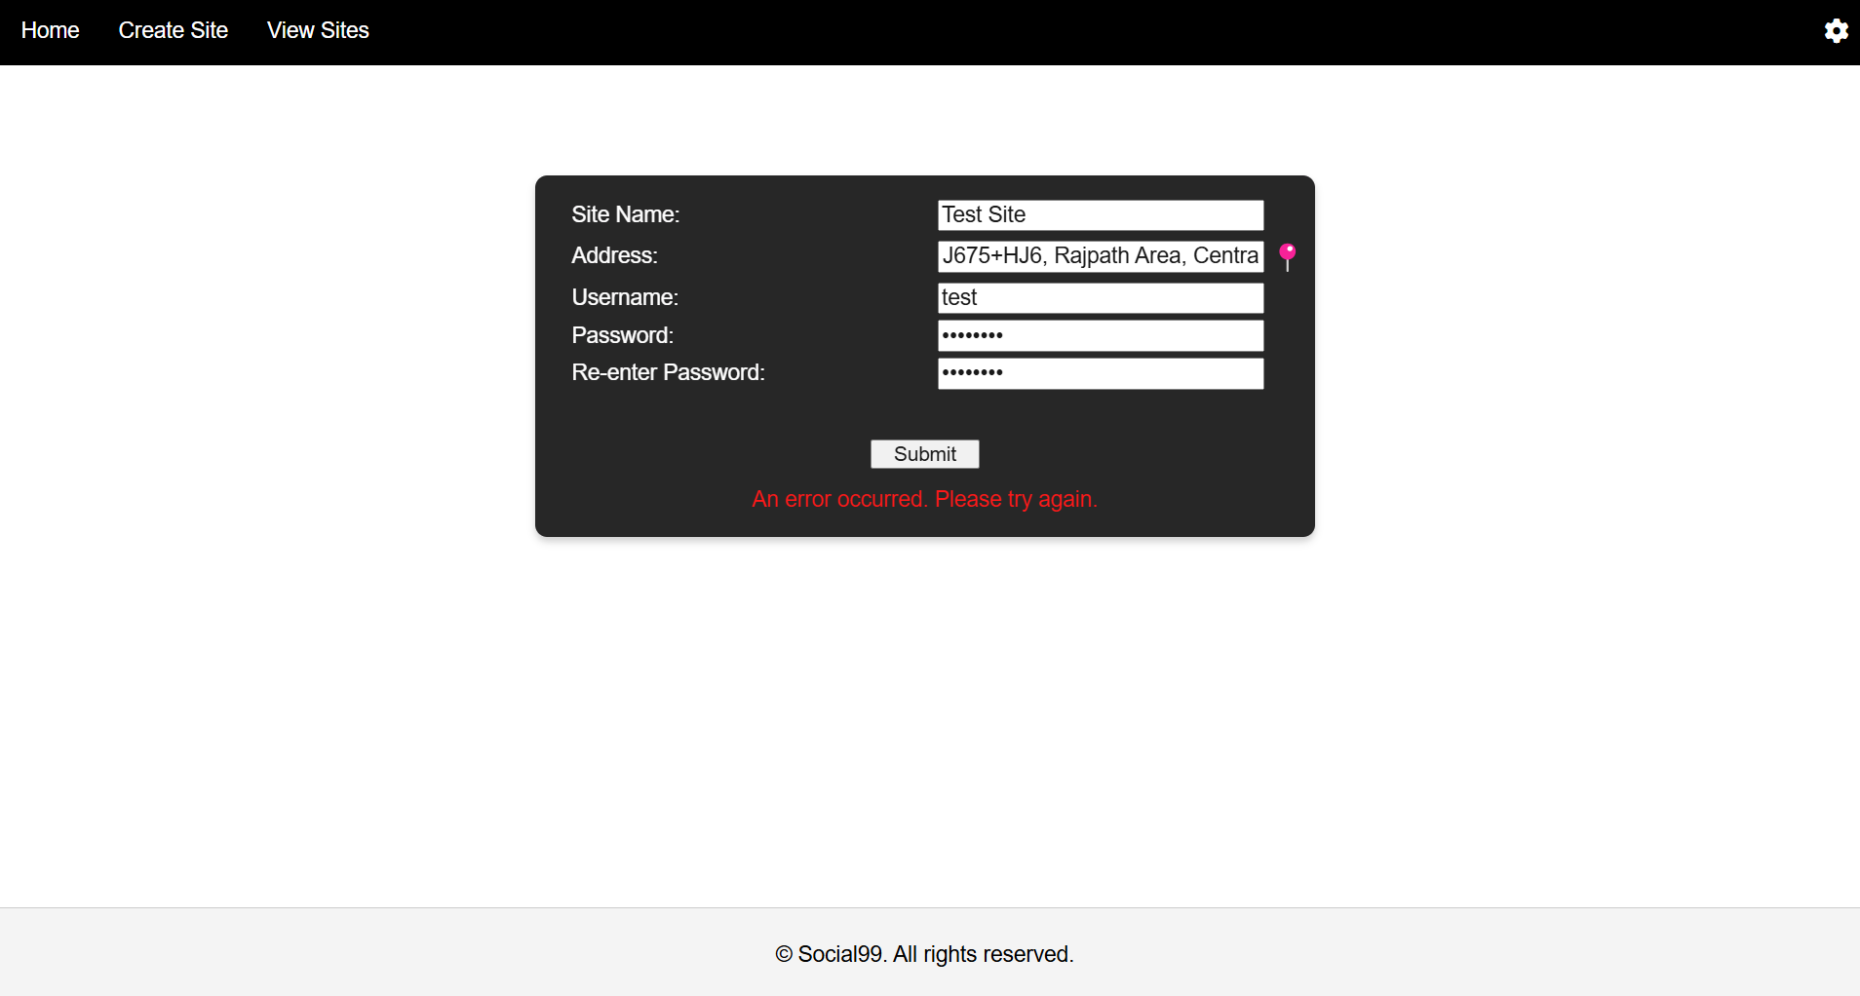

1. Already Login But still access to login page.

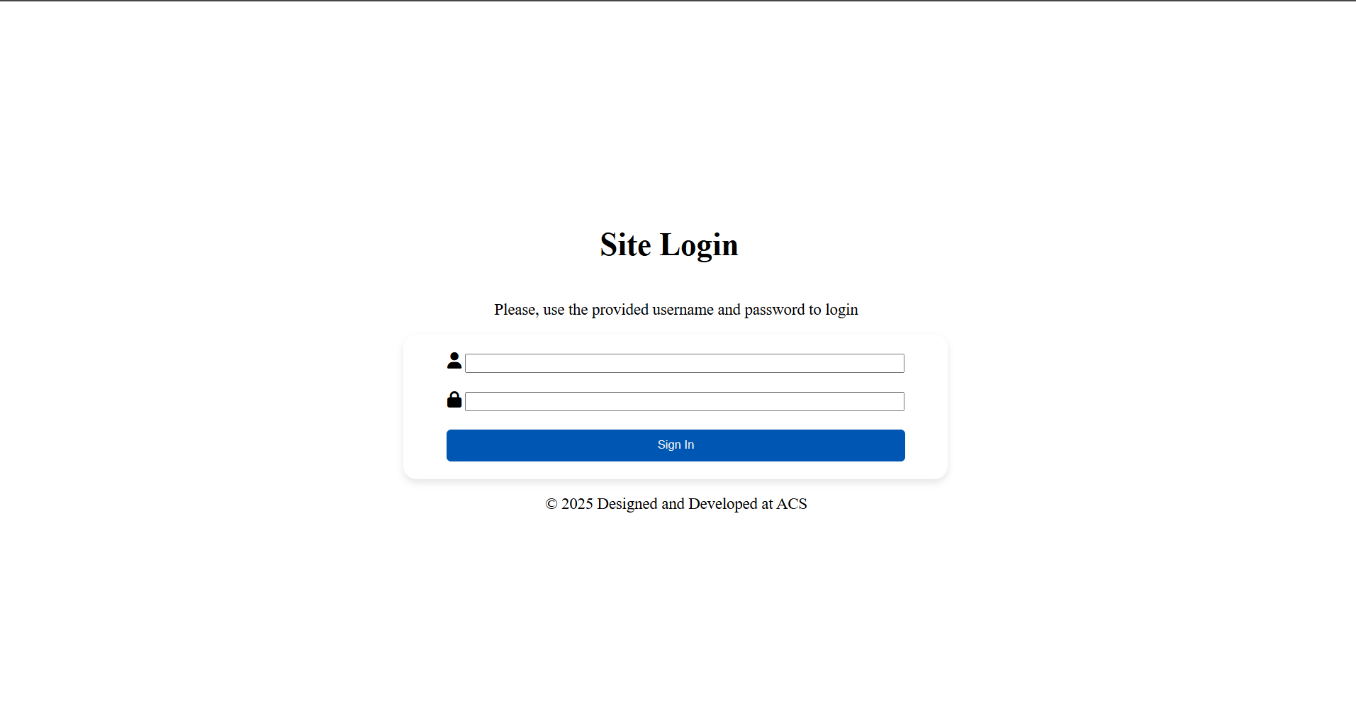

1. Logged in Same Window with two different Site user.

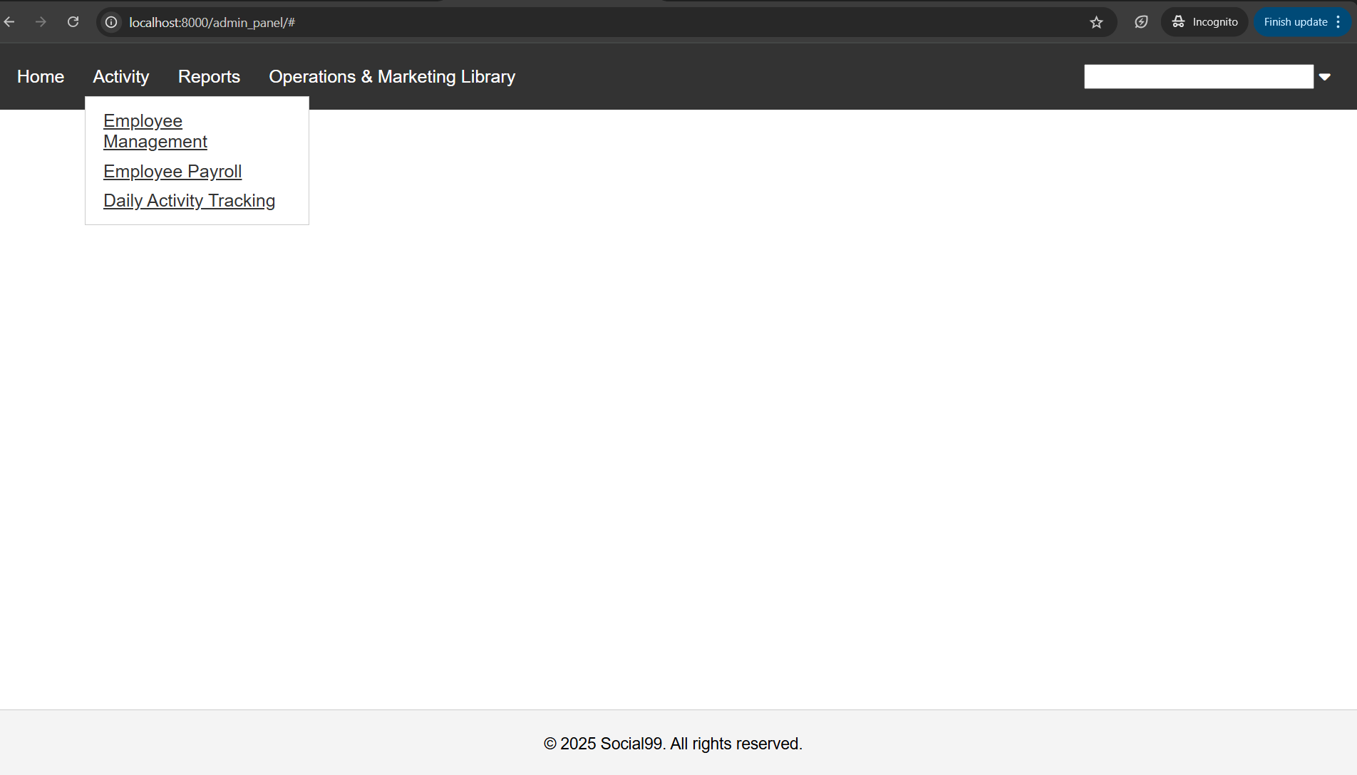

1. Both Menus Opening at same time.

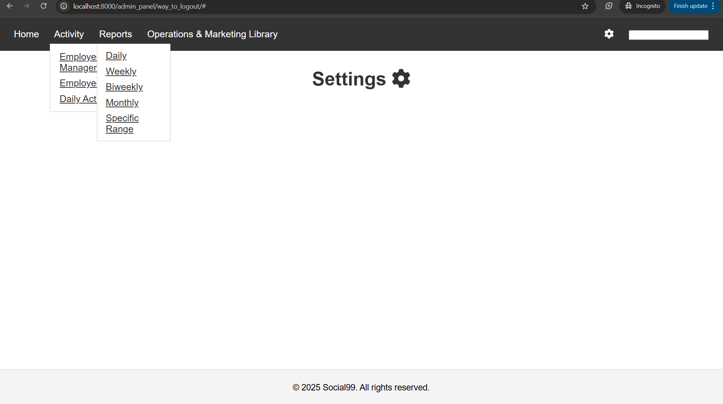

1. Using Site Username and password logged and logged out. But Not able to login again showing message “User is already login in another session”.